Flipbook Tips

As you are reading these notes, it would be best to have the flipbook open so you can follow along. Flipbooks are only accessible from the website. Except for the Sample NMI, you will need to be logged in to www.nickmurraynewsletters.com to view the flipbooks. The link exits on the NMI website.

I. When you click on the link to access the flipbook, you will see the flipbook:
- The flipbook appears in the center. You can click on the text of the NMI to zoom in. Click again and it will zoom out.
- Options are shown on the top or left.
- The arrow next to the text lets you scroll back and forth (see the second image below for the left and right arrows that are highlighted.)
- The bottom section shows a portion of the thumbnails of separate pages, as follows.
- For ebooks, you can click on the chapter’s link in the Table of Contents to get to the chapter you were last reading. This is a quick way to get to the place you were last at. Then scroll forward to the actual page. If you are in the ebook and want to get back to the Table of Contents, you can use the thumbnails at the bottom and click on the navigation arrows to go quickly to the Table of Contents.

II. You can move your mouse to that area on the bottom to see the whole thumbnails. You can click on those thumbnails to bring you directly to that page. For example, if you want to read the last page, click on the last thumbnail:

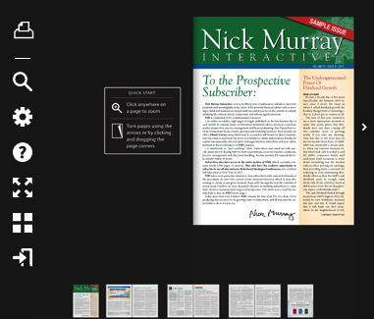

III. The following are the options symbols:

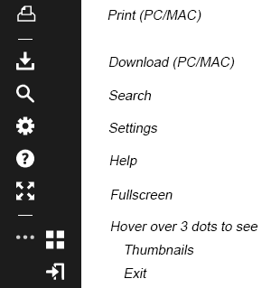

- For flipbooks that are permissible to be printed, click on the print icon, select the desired pages, then click ‘print’.

B. To download, click on the download icon, then select PC or MAC, then save the file.

C. The Search option lets you search the document for a particular word(s) and take you to the page it’s located on. If there are multiple instances of that word(s), it will list all the pages it found the word(s). Select the page you are interested in.

D. The Settings option lets you set zooming options; click on the button you prefer. If, for example, when you zoom, you want to see both left page and right side page (as in a book), click on the ‘Zoom to Double page’.

- To zoom in, click on the text. To zoom out, click again on the text.

- If you zoom in, you will see a black bar on the top of page, with a little button in the middle of the line. Slide that button back and forth with your mouse for smaller/larger view.

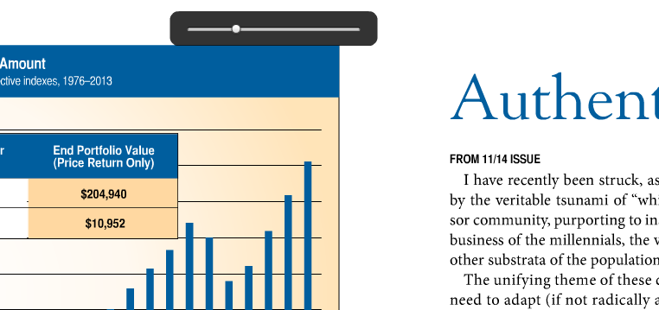

E. The Fullscreen option expands the content to the full screen of your computer. Click on the text itself to increase the size of the text; click on text again to reduce size.

F. Hover over the 3 dots to see the Thumbnails option, which displays each page in thumbnail view. You can click on any of the pages to go directly to that page.

G. Hover over the 3 dots to see the Exit option, which brings you back to nickmurraynewsletters.com website. It takes a few seconds. Alternatively, you can exit your browser tab by clicking on the x in the browser tab area. See the highlighted circle below:

