Flipbook Tips

As you are reading these notes, it would be best to have the flipbook open so you can follow along. Flipbooks are only accessible from the website except for the Sample NMI. For your purchased eBooks, you will need to be logged in to www.nickmurraynewsletters.com to view the flipbooks.

I. When you click on the link to access the flipbook:
- The flipbook appears in the center. You can click on the text of the NMI to zoom in. Click again and it will zoom out.
- Options are shown on the top or left.
- The arrow next to the text lets you scroll back and forth (see the second image below for the left and right arrows that are highlighted.)
- The bottom of the screen shows a portion of the thumbnails of separate pages:

II. You can move your mouse to the thumbnail area to see the full thumbnails. You can click on those thumbnails to bring you directly to each page. For the purchased eBooks, you will see the table of contents. You can click on the chapter to fast forward to your chapter. A new feature is now supported. You can create a bookmark to go to the page you last read. You can create multiple bookmarks. These are available on the eBooks only.

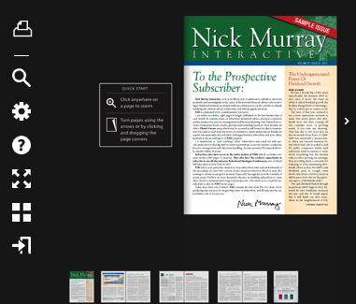

III. The following are the options symbols, which appear on the left of the screen for PDFs that you are allowed to download or print. A new feature has been added to current and future PDFs: ‘Bookmarks’ see below.

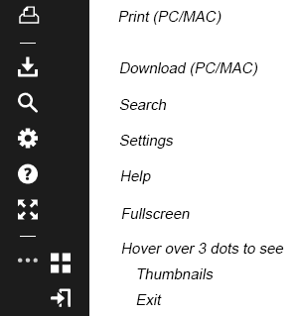

For eBooks, you will see the ‘Bookmarks’ feature shown below. Note that Print and Download features are not shown since eBooks can’t be downloaded nor printed:

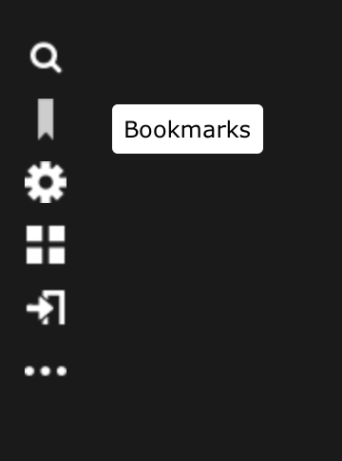

- For flipbooks that are permissible to be printed, click on the print icon, select the desired pages, then click ‘print’.

B. To download, click on the download icon, then select PC or MAC, then save the file.

- When you click on the Bookmarks feature, it will create the following image. To bookmark a page, click on the button ‘Bookmark Current Page’. To go to the page you bookmarked, click on the bookmark icon and then click on the page you would like to go to. You can set up multiple bookmarks.

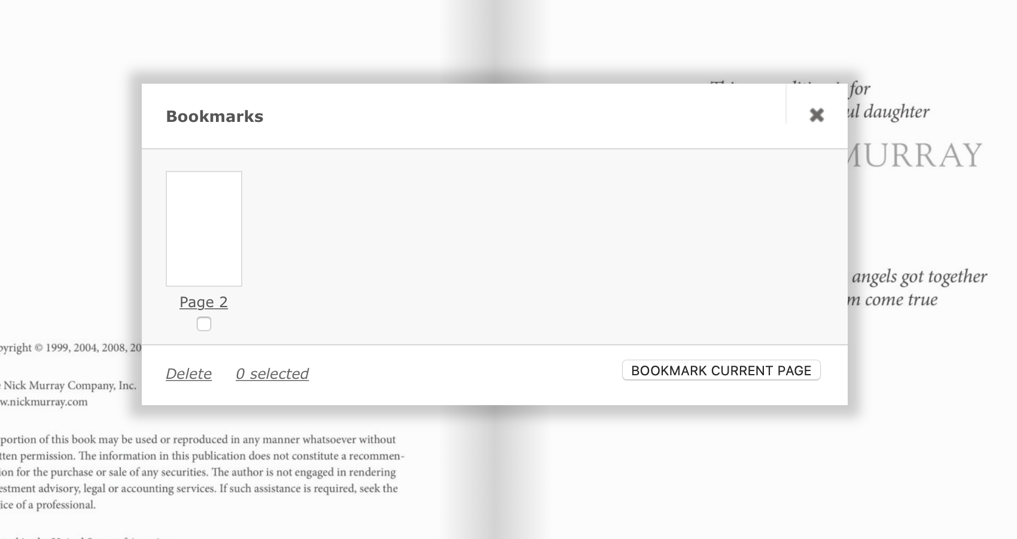

D. The Search option lets you search the document for a particular word(s) and take you to the page it’s located on. If there are multiple instances of that word(s), it will list all the pages it found the word(s). Select the page you are interested in.

E. The Settings option lets you control the amount of zoom; click on the button you prefer. For example, if you want to see both the left and right pages at the same time (as in a book), click on ‘Zoom to Double page.’

- To zoom in, click on the text. To zoom out, click again on the text.

- If you zoom in, move your mouse to hover over the top area. It will show a bar with a little button in the middle of the line. Slide that button back and forth with your mouse to adjust the size of the view.

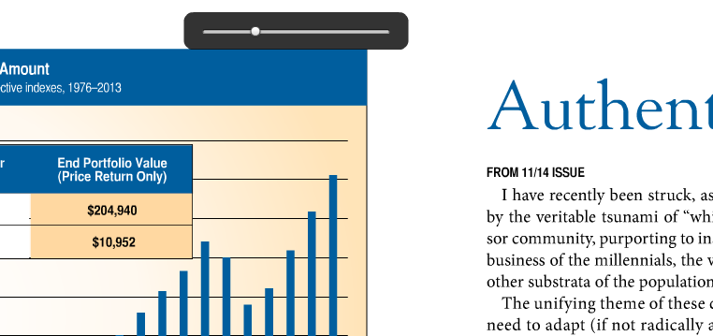

F. The Fullscreen option expands the content to the full screen of your computer. Click on the text itself to increase the size of the text; click on text again to reduce size. Click on the Escape button to go back to original size on screen.

G. Hover over the bottom of screen to see the Thumbnail view of each page. You can click on any of the visible thumbnails to go directly to that page, or click on the left/right arrows to scroll through (and then select the thumbnail of the page you want to view).

