Flipbook Tips

As you are reading these notes, it would be best to have the flipbook open so you can follow along.

Monthly Issues and Client’s Corners on Flipbooks:

Except for the Sample NMI, you will need to be logged in to your account on www.nickmurraynewsletters.com to view in flipbook format. You will be able to download and print.

Ebooks:
If you purchase an ebook, it is not downloadable nor printable. You can access the ebook after logging into your NMI subscription, or if you are not a subscriber, you would log in with the instructions sent you after you purchase on the website.

Please note,
- You have to have access to the internet to view the ebook.
- It is viewable on the desktop, laptop, Ipad, smartphone.
- The ebook does not save the page location that you last read. See the highlighted instructions below (I) on how to quickly get to the page you want.

I. When you click on the link to access the flipbook, you will see the following:

- The flipbook appears in the center. You can click on the text of the NMI to zoom in. Click again and it will zoom out.
- Options are shown on the left.
- The arrows next to the text lets you scroll back and forth (see the second image below for the left and right arrows that are highlighted.)
- The bottom section shows a portion of the thumbnails of separate pages. If you hover over them with the mouse, you will see the full thumbnails. You can click on any thumbnail to get directly to a different page.
- For ebooks, to get to your last-read page quickly, click on the chapter’s link in the Table of Contents to get to the chapter you were last reading. Then either scroll forward to the actual page or click on the thumbnails at the bottom.

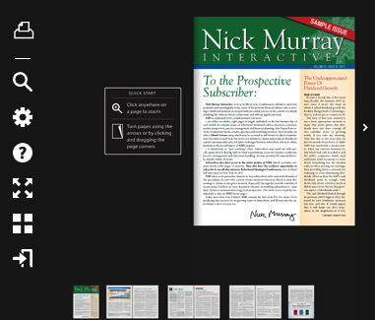

II. The following icon options are described below:

- For flipbooks that are permissible to be printed, click on the print icon, select the desired pages, then click ‘print’. (Note, ebooks cannot be printed)

B. To download, click on the download icon, then select PC or MAC, then save the file. (Note, ebooks cannot be downloaded)

C. The Search option lets you search the document for a particular word(s) and take you to the page it’s located on. If there are multiple instances of that word(s), it will list all the pages it found the word(s). Select the page you are interested in.

D. The Settings option lets you set zooming options; The custom zoom automatically shows single and double pages as appropriate. You can set the zoom size and the page transition type.

In addition,

- To zoom in, click on the text. To zoom out, click again on the text. If you zoom to full screen, you can escape to exit full screen mode.

- If you zoom in, you will see a black bar on the top of page, with a little button in the middle of the line. Slide that button back and forth with your mouse for smaller/larger view. If it is at the lowest setting and too large, you can change the zoom on the settings (see above).

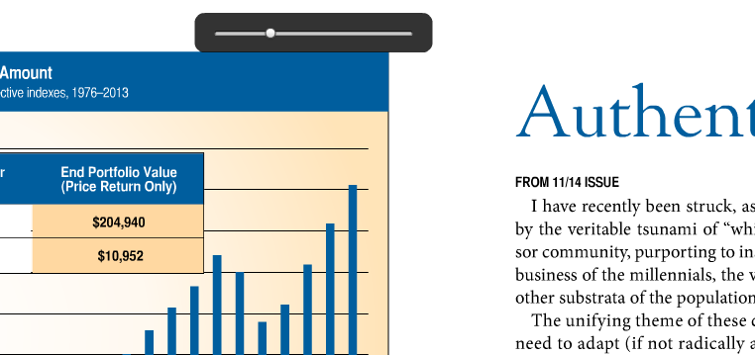

E. You can exit using the icon option (see above) or with your browser (hit back arrow) or hit ‘x’ on the tab of your browser.

